Unit No. 4 Date: 15/02/2011

Three phase short at Point D
Purpose

- To check the operation of Gen. Diff. Protection.
- To check the operation of Overall Diff. Protection.
- To ensure the stability of Gen. Diff. Protection
- To ensure the stability of Over All Diff Protection.
- To Obtain short circuit characteristic of generator
Preparation for Test
    - Created Three phase short point D.
    - Closed the Transfer Bus Isolator to take shorting in the power circuit.
    - Bypassed the 220KV Bus-Bar diff. Protection.
    - Bypassed the tripping of 50LBB protection.
    - Shorted phase side CT for gen diff (both relays LGPG & P343) and 220KV for over all diff protection
    - Rolled the TA set to 3000 RPM
    - Generator and GT Cooling System established.
    - Closed 6.6 KV Excitation Transformer breaker from FB cubical.
- To check the operation of Gen. Diff. Protection
Relay Details
- Make: - AREVA
- Type: - P343
- Settings: - 500mA (1000A)
  - Procedure: -
- Closed the Field Breaker and went on increasing excitation current till operation of Gen diff protection (LGPG) with class A master trip Operation, subsequently with FB tripping.
Observations
The newly commissioned P343 found CT wiring Fault same rectified and operation checked.
Field current: 180 A
Relay operating values: -
 | Current | Expected Current
R Phase | 998A | 1000A
Y Phase | 1000A | 1000A
B Phase | 999A | 1000A

- To check the operation of Overall Diff. Protection
Relay Details
- Make: - ALSTOM
- Type: - KBCH130
- Settings: - 0.2 A (HV Side)

Procedure: -
- Normalized the CT Shorting at TTB1 (Gen Diff Protection Phase side CT)
- Reset all the relays / Flags operated during last test.
- Remove distance protection relay.
- Closed the Field Breaker and go on increasing excitation current till operation of relay. Take the readings.
- Removed Trip block and observe operation of Master trip relay along with FB trip.

Observations

Field current

Relay operating values: -

 | Current | Expected Current
R Phase | 2469 A | 2234 A
Y Phase | 2504 A | 2234 A
B Phase | 2480 A | 2234 A

- Normalized the CT shorting done at TB (Over All Diff Protection 220KV side CTs).

- To ensure the stability of Gen. Diff. Protection
- To ensure the stability of Over All Diff Protection.
- To Obtain short circuit characteristic of generator

Procedure: -
- Closed the Field Breaker and gradually increased excitation.
- Recorded the readings as per table.
- Printed measurement records of P343 relay at every step. Attached here with.

Observations

Gen current On UCP | R Phase | 2000 | 4000 | 6000 | 9000
 | Y Phase
 | B Phase
Field Volt. |  | 40
Field current |  | 326.1
87GT | R Phase | 138 A
220KV | Y Phase | 137 A
On KBCH | B Phase | 138 A
87GT | R Phase | 1960 A
Neutral | Y Phase | 1980 A
Side On KBCH | B Phase | 1980 A
87G | R Phase | 1960 A
On LGPG | Y Phase | 1980 A
 | B Phase | 1980 A
LGPG I Sensitive |  | 2000 A
AVR CT | R Phase | 1980 A
AT | Y Phase | 1980 A
CJJ08 | B Phase | 1980 A
Metering | R Phase | 1980 A
At CFA01 | Y Phase | 1990 A
 | B Phase | 1980 A
EHG | R Phase | 1990 A
At CJJ08 | Y Phase | 1980 A
(CT9) | B Phase | 1980 A
Voltage across 95% Stator E/F |  | 0.72 V | 1.65 V | 2.13 | 3.21 V
Spill Currents of 87G |  | 0 | 0 | 0 | 0
Spill Currents of 87GT |  | 0 | 0 | 0 | 0
- Hand Tripped FB.
- Opened the 220KV transfer Bus Isolator. Released clearance for shorting removal from point D
- Taken 220KV bus-bar diff. Protection, 50LBB Protection in service
- SCC (Field Current Vs Stator Short Circuit Current) plotted with the help of P343 print outs, Attached herewith.
- Readings taken in table above are for all other CTs which are not involved in P343 Circuits. This is for the confirmation of healthiness of All the CTs

SINGLE PHASE TO EARTH FAULT AT POINT “B”
Purpose:
1) To check the operation of Earth Fault. Protection
Relay Details
- Make: - ALSTOM
- Type: - LGPG
- Settings: - 0.024 A
Procedure: -
- Created R Phase to Earth Fault at Point “B “with the help of Earth Rod.
- Closed the Field Breaker and increased excitation current till operation of relay along with FB followed by Master Trip

Observations

Relay operating: - at 0.03 A

REMOVED SHORTING FROM POINT “B ".

GENERATOR OPEN CIRCUIT TEST
Purpose: -
- To obtain open circuit characteristic of generator.

1) To obtain open circuit characteristic of generator
Closed the Field Breaker and increasing excitation to get OCC

Gen. KV GCD |  | 5 KV | 15.75 KV
Pot. Pos. |  | 4.88 | 6.67
Man. Ust. |  | 0.15 | 0.83
Field Volt.
Field current
VT1  Voltages | R-Y | 36.0 V | 109.2 V
VT1  Voltages | Y-B | 36.0 V | 109.5 V
VT1  Voltages | B-R | 36.0 V | 109.5 V
VT1  Voltages | Open delta | 0.01 V | 0.4 V
VT2  Voltages | R-Y | 36.0 V | 109.6 V
VT2  Voltages | Y-B | 36.0 V | 109.6 V
VT2  Voltages | B-R | 36.0 V | 109.5 V
VT3  Voltages | R-Y | 36.0 V | 109.6 V
VT3  Voltages | Y-B | 36.0 V | 109.6 V
VT3  Voltages | B-R | 36.0 V | 109.5 V
VT4  Voltages | R-Y | 36.0 V | 109.6 V
VT4  Voltages | Y-B | 36.0 V | 109.4 V
VT4  Voltages | B-R | 36.0 V | 109.4 V
VT4  Voltages | Open delta | 0.01 V | 0.5 V
Voltage across 95% Stator E/F |  | 0.2 V | 0.5 V

- Printed measurement records of P343 relay at every step. Attached here with.
- OCC (Field Current Vs Stator Open Circuit Voltage) plotted with the help of P343 print outs, Attached herewith.
- Spill currents of overall differential relay indicate healthiness of Generator transformer and UAT.

Time and Motion Programme for Dynamic Testing
In view of saving the costly oil consumption during dynamic testing, it is decided to complete the dynamic testing activity in shortest possible time. Hence it is utmost important to carry out the activities involved in dynamic testing with proper co-ordination and keen eye on timing without compromising with safety and the very purpose of the dynamic test.
Following are the activities and responsibilities of the staff with estimated time frame
Sr. No. | Activity | Estimated Time | Actual  Date / Time | Responsibility
1. | Create 3 Phase Short at Point D | Well in advance | 14/02/2011 | EM –II in co-ordination with GCR
2. | Bypass 220KV Bus Bar Protection | Before starting the testing | 15/02/2011 7.00 Hrs | Test-II in co-ordination with GCR
3 | Bypass the tripping of 50LBB protection put trip block at 11A of 50LBB. | Before starting the Dynamic testing | 15/02/2011 7.05 Hrs | Test -II
4 | Short phase side CT for gen diff and 220KV for over all diff protection | Before starting the Dynamic testing | 14/02/2011 | Test –II
5 | Close the Transfer Bus Isolator to take shorting in the power circuit. | Before starting the Dynamic testing | 15/02/2011 7.15 Hrs | EM –II in co-ordination with GCR
6 | Roll the TA set to 3000RPM, Establish Gen and GT Cooling and hand over to testing for dynamic testing | 0(0) min | 15/02/2011 7.40 Hrs  0(0) min | Operation staff Unit 4  Please refer Note No.1 below
7 | Operation of Generator Diff protection | 5(5) Min | 15/02/2011 9.20 Hrs 5(5) min | Test – II
8 | Normalization of Phase side CT for Gen. Diff. Protection | 5(10) min | 15/02/2011 10.10 Hrs | Test – II  Please refer Note No. 2
9 | Operation of over All Diff protection | 5(15) min | 15/02/2011 10.15 Hrs 5(10) min | Test-II
10 | Normalization of 220 KV side CTs for Over All Diff. Protection | 5(20) min | 15/02/2011 10.20 Hrs 5(15) min | Test – II
11 | Short circuit test | 10(30) | 15/02/2011 10.25 Hrs 10(25) min | Test – II
12 | Opening of Transfer Bus Isolator on clearance from Testing | 5(35) | 15/02/2011 10.35 Hrs 5(30) min | EM –II in co-ordination with GCR
13 | Removal of shorting from Point D | ---- | 15/02/2011 | EM –II in co-ordination with GCR
14 | Create R phase to Earth at Gen Terminal | 5(35) | 15/02/2011 10.40 Hrs 5(35) min | EM-II
15 | Stator Earth Fault Test | 5(40) | 15/02/2011 10.45Hrs 5(40) min | Test – II
16 | Removal of Earth Rod from Gen Terminals | 5(45) | 15/02/2011 10.50 Hrs 5(45) min | EM-II
17 | Taking 220KV bus bar Protection in service, Taking 50LBB in service | 10 (45) | 15/02/2011 | Test – II
18 | Open Circuit Test | 15(60) | 15/02/2011 10.55 Hrs 12(57) min | Test – II
19 | Hand trip the Machine and bring TA set to Barring Speed | 45(105) | 15/02/2011 11.05 Hrs | Operation staff Unit 4
20 | Normalization of Excitation Transformer HV links | 30(135) | 15/02/2011 11.50 Hrs 45(102) min | EM-II
22 | Normalization of modifications done in Excitation and Gen Protection for dynamic Test. | 30(135) | 15/02/2011 11.50 Hrs 45(102) min | Test – II
23 | Release of clearance for rolling and synchronization | 0(135) | 15/02/2011 11.50 Hrs 0(102) min | Test – II and EM-II
24 | Rolling and synchronization | 30(165) | 15/02/2011 12.27 Hrs 37(139) min | Operation Staff Unit 4

Activity No. 12 & 14 is parallel activity
Activity No. 13 is independent activity, Expected to finish by activity No.22.
Activity No. 17 can be performed during activity No. 13, 14, 15 &16
Actual time required for dynamic testing i.e. from M/C handover for Dynamic Testing to Synchronisation is 139 min. whereas predicted time was 165 min. the extra time consumed due to unpredicted problems is excluded.
Report submitted for appraisal please

Note 1: The M/C was handed over to Testing at 07.40 Hrs but due to non operation of excitation from remote test could not started at 07.40 Hrs. after investigation and rectification of the problem.
Detailed analysis of problem: The modifications for excitation dummy load test in controller card, which was carried out before the dynamic testing are slightly different than the modification required for dyn. Test. ( Switch position differs) , the switch was rotary micro switch and exact swich position reading is very difficult hence it got selected wrongly, same corrected and test started at 09.20 Hrs. due to this has wasted 100 min.
Note 2: while checking the operation of Gen Diff. Protection on P343, The relay setting was done with baised differential function as it was adopted in LGPG earlier. The CT connections required for Baised differential mode is different than it was done. Actual connections done as per previous circuitry and it was applicable for High impedance differential mode of operations, which is mostly used for Generator Differential function. To rectify this problem again the relay manual referred and CT wiring corrected. The relay put in service. Then the dynamic testing proceeded further at 10.10 Hrs. This has wasted 45 Min
Note 3: The estimated time from M/c tripping to Modification normalisation was 45 + 30 toal 75 Min. But only due to extra efforts and co operation from Electrical and Testing staff it has completed the activity in total 45 Min. This must be appreciated.

Executive Engineer (T,I&C) Executive Engineer (MPD)

Superintending Engineer (O-II)
Superintending Engineer (M)

General Manager – I
KhTPS

Chief General Manager
TPS Khaparkheda

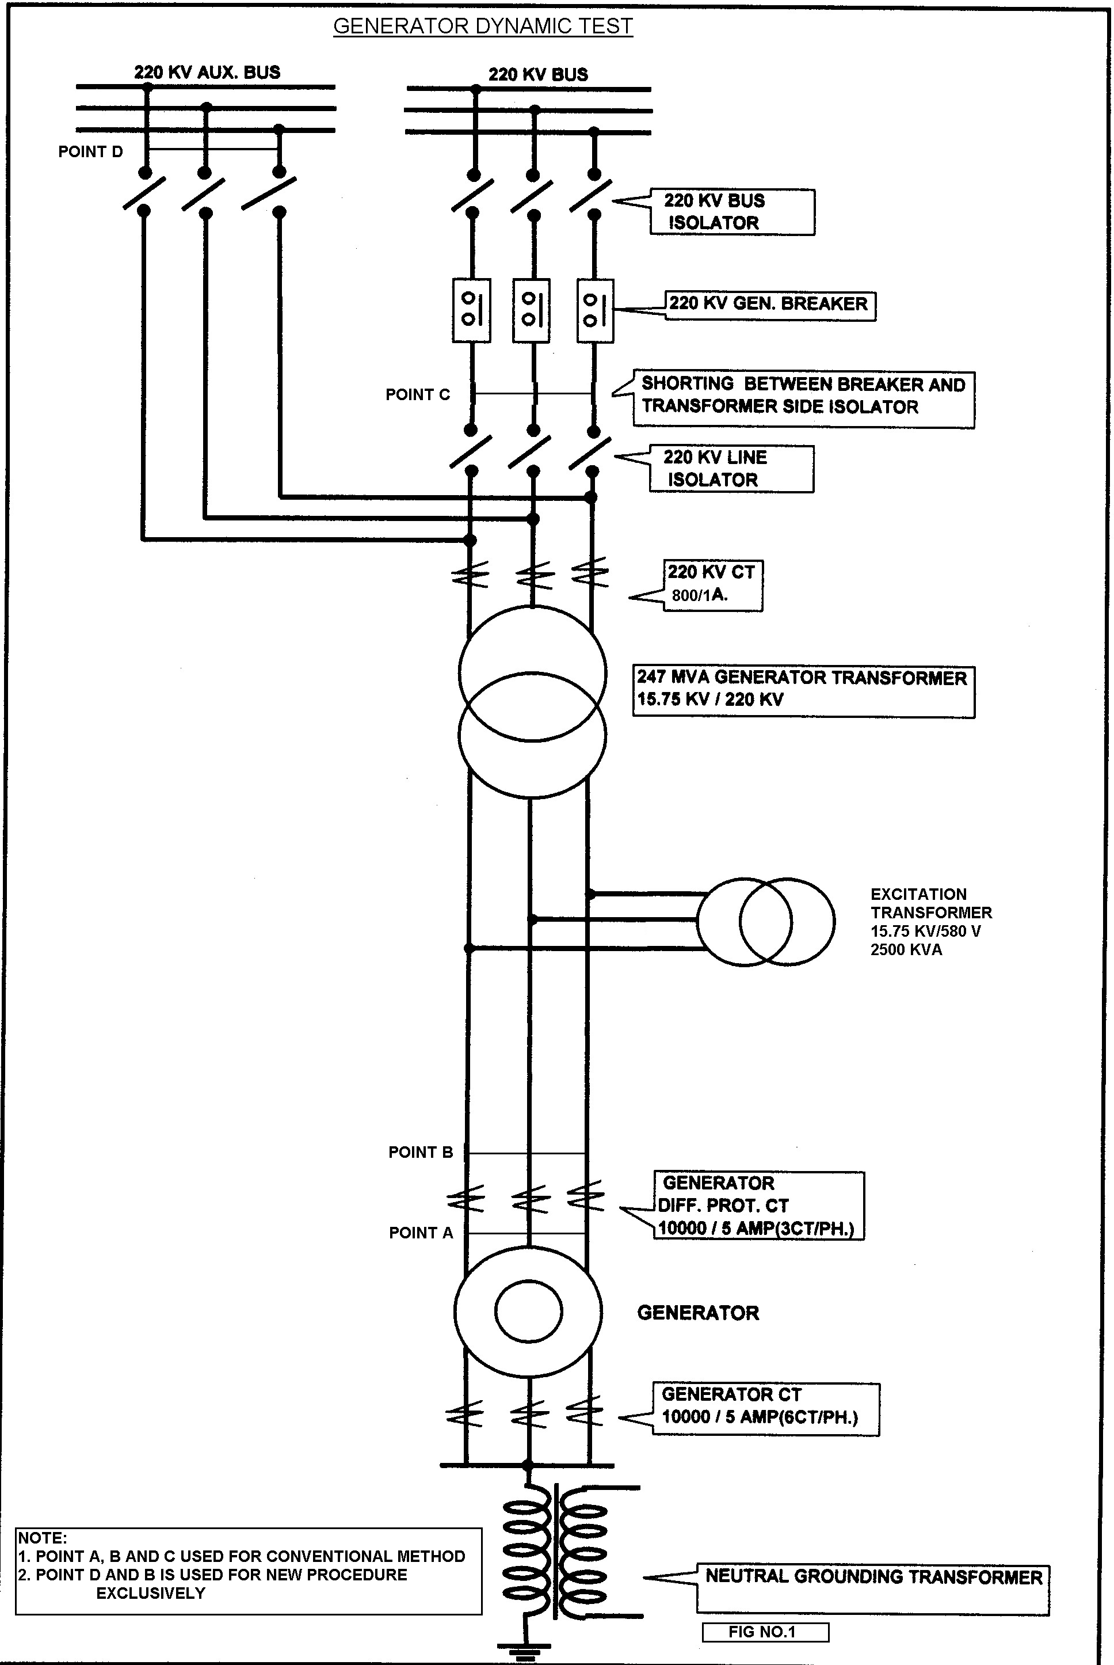
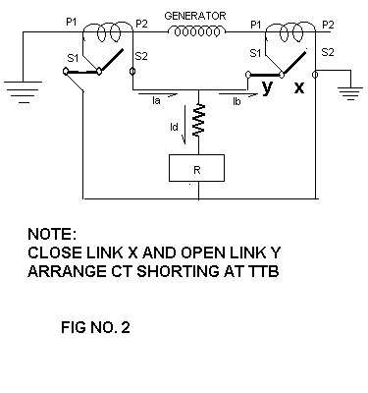

Close link X and Open link Y

Arrangement of CT shorting at TTB

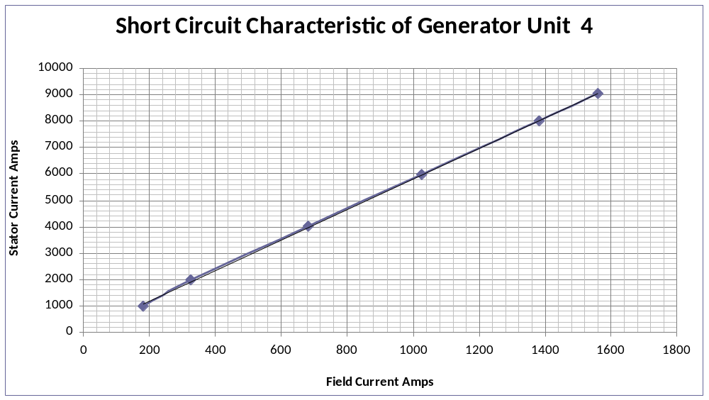

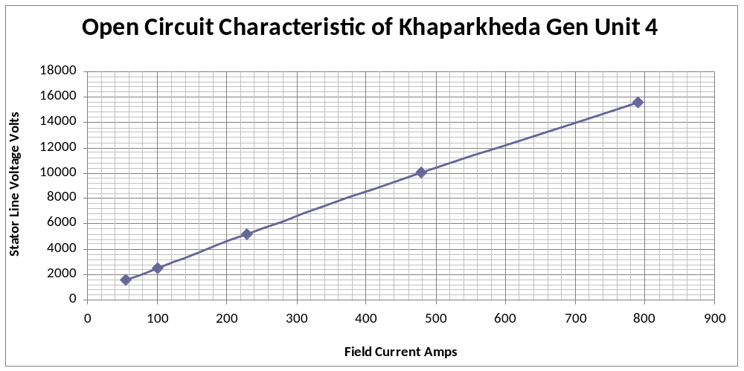
Charactristics ploted from reading print outs taken from P343 relays during Short Circuit test and Open Circuit Test.
Calculated p.u. Impedance of generator = Field current for rated Current during SCC
Field current for rated voltage during OCC
= 1560
789.8
= 1.975 p.u.
As per Name plate details p.u. Impedance of generator = 1.99 p. u.
(It is fairly matching)
Losses Measurement during Dynamic testing
Core Loss ( Fixed Loss):
The combine Fixed Losses during OCC at rated voltage is 196.1 KW (Measured on P343)
This includes GT +UAT
Copper Loss ( Variable Loss):
The copper Loss during SCC at rated Current is 516.9 KW (Measured on P343)
This includes GT only.
Hence Total GT losses at full load (250 MVA)
=Core Loss of GT + Copper Loss of GT (at ambient temp)
= 196.1 * 0.9 + 516.9
= 176.49 + 516.9
=693.39 KW
as per factory test report of GT the losses are 685.33 KW

